Cycle count error:

1. Create cycle count for ITEM 8441B001AA

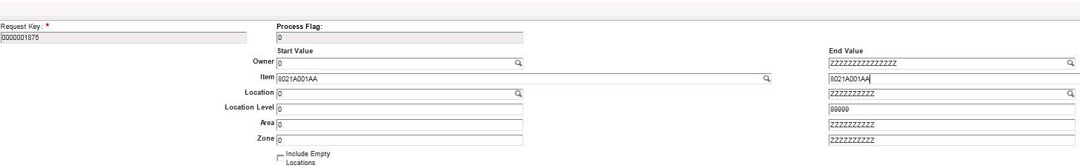

1. We will release the tasks for the ITEM

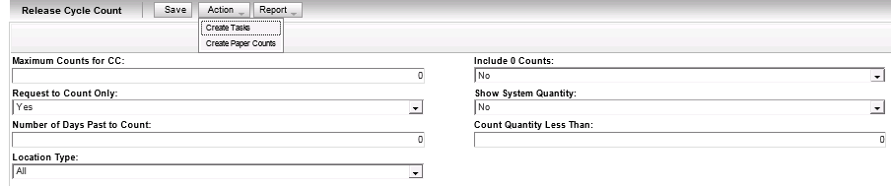

1. On our task screen we have all the pending tasks for the ITEM including the locations, sku and status

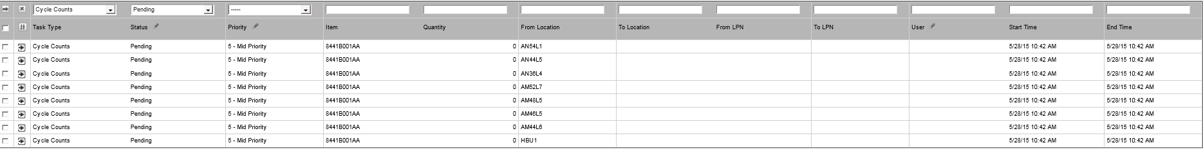

1. Log on to the RF

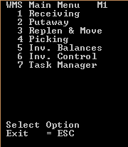

1. Navigate to option “7” task manager

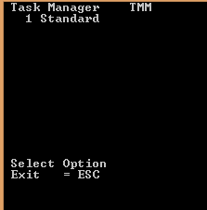

1. Choose the task that we would like to do on the RF i.e. “cycle counts”

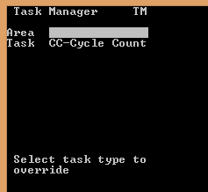

1. We receive the 1st task on the RF scanner

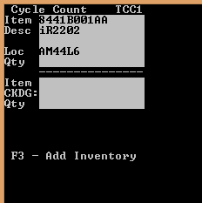

1. I will complete the task on the scanner capturing the incorrect QTY in that location

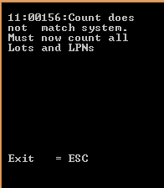

1. I will press ESC and go back to the same task after receiving the above error message

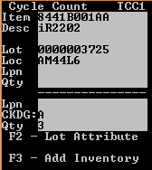

1. After completing the above task we receive the following error message on the scanner

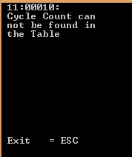

1. I checked the task on the console and it is “in process”

